# Resize Errors Test Ad for MRAID 2

## Goal of Ad

This ad will test that the container throws appropriate errors when resize-related methods and properties are used incorrectly. All expected errors are caught by the creative and reported to the console. With the exception of the last few tests, a compliant container will not resize the ad. Instead it will throw errors that the creative can report.

## This Creative Tests:

**MRAID Methods Tested:**

* mraid.resize()
* mraid.get/setResizeProperties()
* mraid.getMaxSize()
* mraid.add/removeEventListener()
* mraid.getState()
* mraid.getVersion()

**MRAID Events Watched:**

* ready event
* error event
* stateChange event

**Other:**

* Calling resize() before setting properties
* Calling setResizeProperties with invalid values
* Calling setResizeProperties with width and height less than 50x50
* Calling setResizeProperties with width and height too large for the screen to also show a close button
* Resizing too wide so close indicator off screen to the west or east
* Resizing too tall so close indicator off screen to the north or south
* Changing orientation so allowOffscreen=false is not effective

## Behavior of Ad

**Initial/Default State**

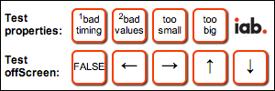

* Ad begins as a 300x100 banner
* There are no initial or automatic ad behaviors beyond registering for the ready event
* Tapping on the buttons generate error conditions
* Console output expected
  + ResizeErrTester(2):OK mraid state is ready
  + ResizeErrTester(2):OK mraid.getVersion()
  + ResizeErrTester(1):adding listener for error
  + ResizeErrTester(1):adding listener for stateChange

**User Interaction 1 – Click “1 bad timing”**

This test should be run first and attempts to resize before setting any resizeProperties values.

*“Note that resize() relies on parameters that are stored in the resizeProperties JavaScript object. Thus the creative must set those parameters via the setResizeProperties() method BEFORE attempting to resize(). Calling resize() before setResizeProperties will result in an error.”*

* The “bad timing” button should be clicked first before any other interaction
* Clicking this button attempts to call mraid.resize before setting any properties
* This interaction should not change the ad status, size or appearance
* Console output expected:
  + ResizeErrTester(2):OK mraid.getResizeProperties()
  + ResizeErrTester(3): ERR: mraid error caught from resize...

**User Interaction 2 – Click “2 bad values”**

This test should be run second and attempts to resize after setting invalid values for resizeProperties.

*“Note that width, height, offsetX and offsetY are required and have no default properties. If the ad creative attempts to call resize() before* ***[properly]*** *setting these four properties, the container will leave the ad in its current state and return an error.”*

* Click the “bad values” button second during testing
* Clicking this button attempts to call mraid.setResizeProperties twice with invalid values – once with string values instead of integer and once with incomplete values
* This interaction should not change the ad status, size or appearance
* Console output expected (two errors)
  + ResizeErrTester(3): ERR: mraid error caught from setResizeProperties...
  + ResizeErrTester(3): ERR: mraid error caught from setResizeProperties...

**User Interaction 3 – Click “too small”**

This test attempts to resize with resizeProperties set to less than 50px wide and 50px high.

*“This requirement also means that a resized ad must be at least 50x50 pixels, to ensure there is room on the resized creative for the close event region.”*

* Click the “too small” button at any time during testing
* Clicking this button attempts to call mraid.setResizeProperties with values less than 50x50
* This interaction should not change the ad status, size or appearance
* Console output expected
  + ResizeErrTester(3):ERR: mraid error caught from setResizeProperties...

**User Interaction 4 – Click “too big”**

This test attempts to resize with resizeProperties set to greater than the screen size.

*“Note: resize should not be used for ad creative that expands to full-screen (or larger) size: for such creative executions expand() should always be used. Resize will always result in a nonmodal size change, and some portion of the app should always remain visible to the end user.*

*If the parameters are out of range, then the error event identifies the exception.*

*For example, an error will occur if an ad sets allowOffscreen to "false" but sets the width and height of the resize to be too big to actually fit on the screen.”*

* Click the “too big” button at any time during testing
* Clicking this button attempts to call mraid.setResizeProperties with values that are too large for the screen because the close button would be off screen
* This interaction should not change the ad status, size or appearance
* Console output expected
  + ResizeErrTester(2):OK mraid.getMaxSize(x,y)
  + ResizeErrTester(3): ERR: mraid error caught from setResizeProperties...

**User Interaction 5 – Test resize directions arrows with offScreen “TRUE”**

These tests attempt to resize with resizeProperties greater than the screen size in one direction such that the location of the close button would display outside the container area.

*“allowOffscreen: (optional) tells the container whether or not it should allow the resized creative to be drawn fully/partially offscreen.*

*A resized ad must position itself such that the entire close event region appears onscreen. If the container/SDK detects that a request to resize will result in the close event region being offscreen, the container/SDK should return an error, and ignore the resize.”*

* Click the first Test offScreen button at least twice until the label displays “TRUE” – this sets the offScreen resize property to “true” which allows a resized ad to be display partially off the screen.
* Click each of the arrow buttons
  + left: attempt resize too wide with close indicator off screen to the west
  + right: attempt resize too wide with close indicator off screen to the east
  + up: attempt resize too tall with close indicator off screen to the north
  + down: attempt resize too tall with close indicator off screen to the south
* This interaction should not change the ad status, size or appearance
* Console output expected
  + ResizeErrTester(2):OK mraid.setResizeProperties()
  + ResizeErrTester(2):OK mraid.getMaxSize(x,y)
  + ResizeErrTester(2): ERR: mraid error caught from setResizeProperties...
  + ResizeErrTester(3): ERR: mraid error caught from resize...

**User Interaction 6 – Test resize direction arrows with offScreen “FALSE”**

These tests attempt to resize with x-offsets and y-offsets that require the container to reposition the ad back on screen. Theses tests should succeed in resizing the ad unit in portrait orientation.

*“When allowOffscreen is set to False, the SDK will do its best to move the default (banner) ad container to ensure that the resized creative fits on the screen. For example, if ad is on the top of the screen, and ad wants to resize upwards by 50 pixels, then the SDK will move the default (banner) ad 50 pixels down and then execute the resize.”*

* Click the first Test offScreen button at least twice until the label displays “FALSE” – this sets the offScreen property to “false” which attempts to move a resized ad so that it displays on the screen.
* Click each of the arrow buttons
  + left: resizes to full width with close indicator in top-left  
    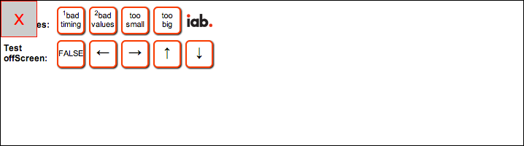
  + right: resizes to full width with close indicator in top-right  
    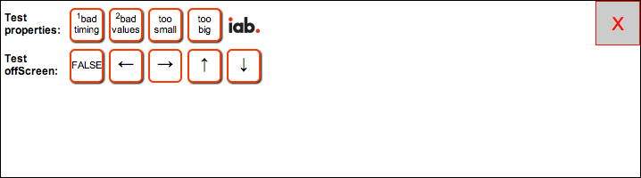
  + up: resizes to full height with close indicator in top-left  
    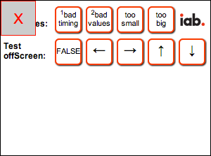
  + down: resizes to full height with close indicator in bottom-right  
    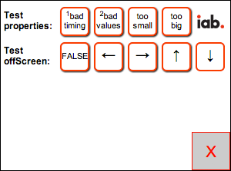
* Click the “X” close button to return to the default state and display
* Unlike the other tests, these interactions should change the ad status, size and appearance
* Console output expected
  + ResizeErrTester(2):OK mraid.setResizeProperties()
  + ResizeErrTester(2):OK mraid.getMaxSize()
  + ResizeErrTester(2):OK mraid.setResizeProperties()
  + ResizeErrTester(2):OK mraid.resize()
  + ResizeErrTester(2):OK state changed to: default

**User Interaction 7 – Change the orientation to see the effect of allowOffScreen=false**

This test reviews the container’s response to a resized ad unit that is valid for one orientation, but not another.

*“allowOffscreen cannot solve all positioning issues. For example, if an ad successfully resizes in landscape orientation, but then becomes larger than the size of the screen due to an orientation change to portrait, the setting of allowOffscreen to false will have no effect, as there is no way the container/SDK can successfully reposition a landscape creative to fit on a portrait screen.”*

* Ensure the device is physically in portrait mode where screen height is greater than screen width
* Click the first Test offScreen button at least twice until the label displays “FALSE”
* Click the of the down arrow so the ad resizes to full height with close button in the bottom-right
* Rotate the device so it is physically in landscape mode where the screen width is greater than screen height
* Either the close button or the testing buttons are no longer on screen, but some of the ad is still visible
* Rotate the device back to portrait
* Click the “X” close button to return to the default state and display
* These interactions should return the ad unit to exactly the same location as it started
* Console output expected
  + ResizeErrTester(2):OK mraid.setResizeProperties()
  + ResizeErrTester(2):OK mraid.getMaxSize()
  + ResizeErrTester(2):OK mraid.setResizeProperties()
  + ResizeErrTester(2):OK mraid.resize()
  + ResizeErrTester(2):OK state changed to: default

**User Interaction 8 – Click “too big” to confirm orientation-aware getMaxSize**

This test simply outputs the values of getMaxSize so that the tester can confirm that the values change after changing the device orientation.

* Click the “too big” button at any time during testing
* Change the orientation of the device
* Click the “too big” button again
* Console output must confirm that the width values and height values have changed to represent the new dimensions for maxSize.
* Console output expected
  + ResizeErrTester(2):OK mraid.getMaxSize(x,y)
  + ResizeErrTester(3):ERR: mraid error caught from setResizeProperties...
  + ResizeErrTester(2):OK mraid.getMaxSize(y,x)
  + ResizeErrTester(3):ERR: mraid error caught from setResizeProperties...

**User Interaction 9 – Toggle offScreen to confirm orientation-aware getResizeProperties**

This test simply outputs the values of getResizeProperties so that the tester can confirm that the values change after changing the device orientation.

* Click the first Test offScreen button until the label changes
* Change the orientation of the device
* Click the first Test offScreen button again so label changes back
* Console output must confirm that the width and height values have changed to represent the new dimensions for resize
* Console output expected
  + ResizeErrTester(2):OK mraid.getResizeProperties(x,y)
  + ResizeErrTester(2):OK mraid.getResizeProperties(y,x)

## MRAID 2 Compliance Checklist

A container/SDK running this test creative must exhibit these behaviors to prove MRAID compliance.

* Ad remains in default status, appearance and location except for resizing when offScreen is false
* Ad returns to default status, appearance and location after clicking the close indicator even after changing orientation
* Console logs match those identified in the User Interactions
* None of the following console messages can appear
  + ResizeErrTester(3):ERR calling getState, mraid is not defined
  + ResizeErrTester(3):ERR mraid state is not recognized - tests cannot continue
  + ResizeErrTester(3):ERR calling getVersion, mraid is not defined
  + ResizeErrTester(3):ERR version mismatch; cannot run resize tester
  + ResizeErrTester(2):ERR mraid resize tester unit disabled

## URL for this Creative

* http://webtester.mraid.org/compliance/units/resize-err.full.html - HTML page
* http://webtester.mraid.org/compliance/units/resize-err.htm - HTML fragment

## Additional Notes

If your container testing environment does not support capturing console.log output from JavaScript, you can change the value of variable “useAlert” to mirror all logging to pop-up alert boxes. Alternately, you can use the on-screen console. To see the ad unit output, click the IAB logo. This will display the console view.

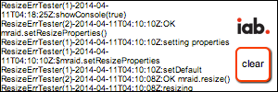

In this mode, you can scroll through the logging output and click the “clear” button to clear the screen. Clicking the IAB logo again will return the ad to the standard display with the testing buttons.

The debugging output level can also be adjusted to see more info for troubleshooting; use the variable “logLevel”.

Source code is thoroughly documented.

Developer-testers can use a supplied mock-object file “mraid.mock.js” or the WebTester at http://mraid.webtester.org/ for browser-based testing.